import turtle  
t = turtle.Turtle()  
t.speed(10)  
for i in range(4):  
 t.forward(200)  
 t.right(90)  
turtle.done()

2.

import turtle  
t = turtle.Turtle()  
t.speed(10)  
t.goto(0,0)  
t.goto(12,235)  
t.goto(238,340)  
t.goto(0,0)  
turtle.done()

3.

import turtle  
t = turtle.Turtle()  
t.speed(10)  
turtle.bgcolor('yellow')  
t.circle(80)  
turtle.done()

4.

import turtle  
t = turtle.Turtle()  
t.speed(100)  
t.circle(120,360)  
turtle.done()

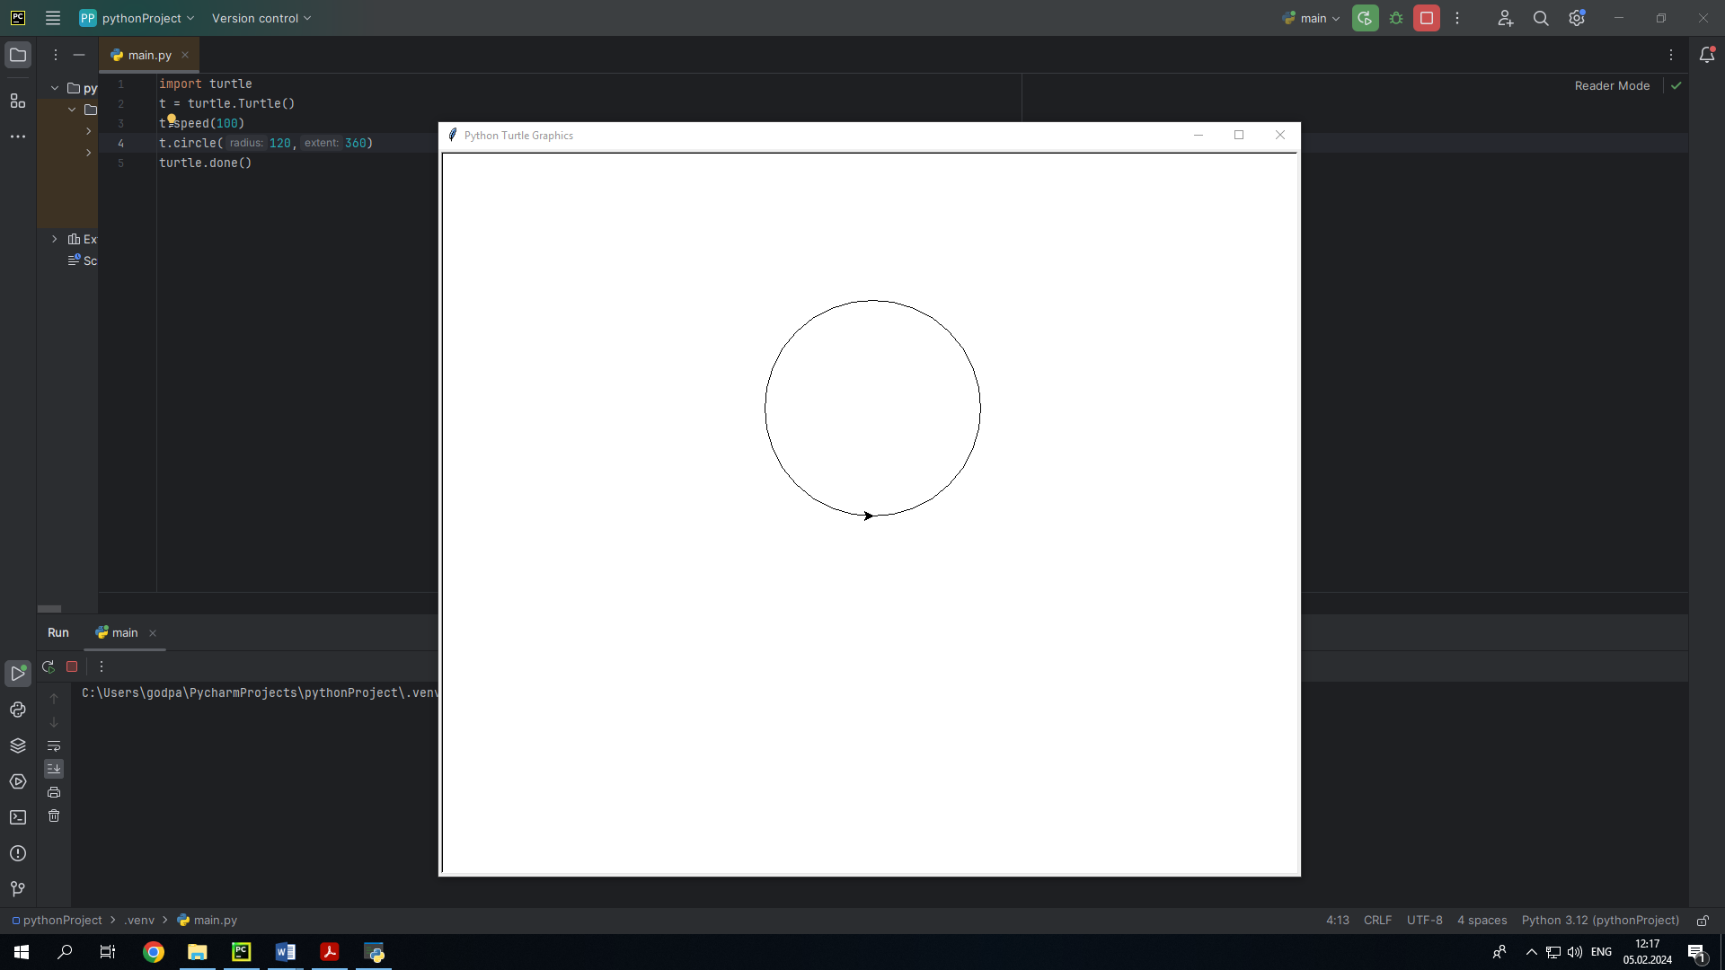

или

from turtle import *  
a = 170  
b = 90  
for i in ('yellow','black'):  
 color(i)  
 circle(a, 45)  
 circle(b, 90)  
 circle(a, 90)  
 circle(b, 90)  
 circle(a, 45)  
turtle.done()

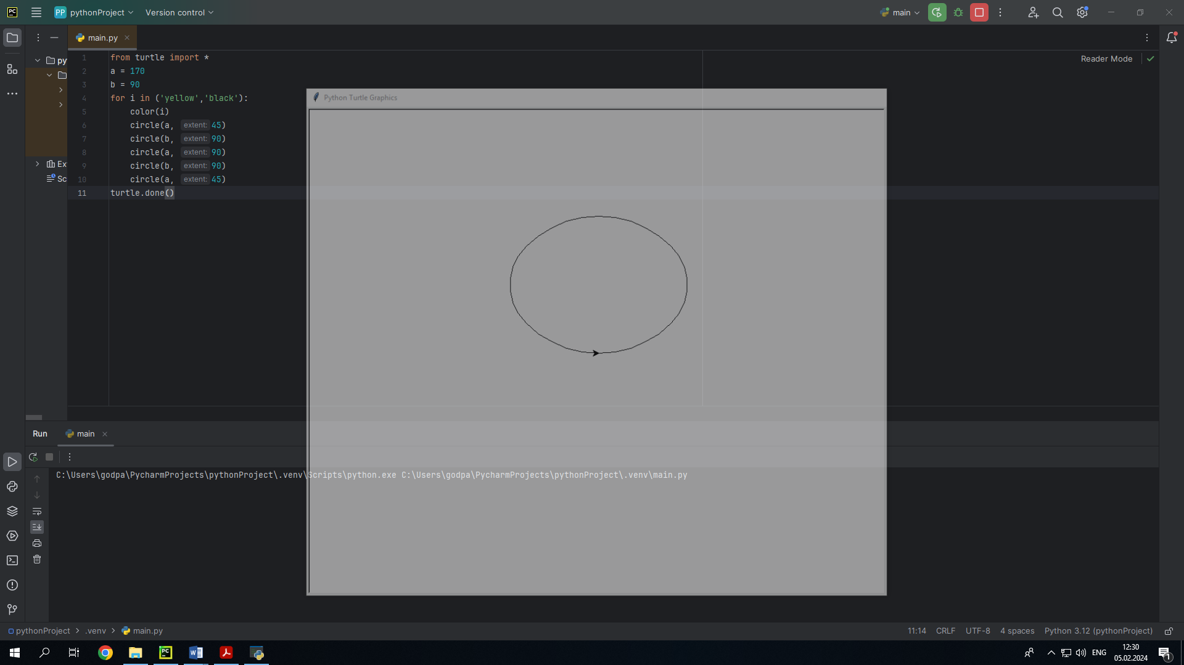

5.

import turtle  
t = turtle.Turtle()  
t.speed(10)  
t.color('blue')  
t.fillcolor('red')  
t.begin_fill()  
for i in range(5):  
 t.forward(250)  
 t.right(144)  
t.end_fill()  
turtle.done()

6.

import turtle  
colors = ['yellow' , 'ping' , 'blue' , 'red' , 'purple' , 'yellow']  
t = turtle.Turtle()  
t.speed(0)  
for i in range(15):  
 color = colors[i % len(colors)]  
 t.pencolor(color)  
 t.circle(50)  
 t.penup()  
 t.right(30)  
 t.pendown()

8.

import turtle  
t = turtle.Turtle()  
for i in range(4):  
 t.forward(200)

t.circle(-15, 50)  
 t.right(40)  
 t.color('black')  
 t.speed(10)  
t.forward(100)  
t.right(90)  
t.penup()  
t.forward(100)  
t.left(90)  
t.write('>>>Hello', False, align='left', font=('Arial', 10, 'normal'))  
turtle.done()

13.

import turtle  
turtle.shape("turtle")  
turtle.color("blue")  
turtle.penup()  
def forward():  
 turtle.forward(50)  
def backward():  
 turtle.backward(50)  
def left():  
 turtle.left(45)  
def right():  
 turtle.right(45)  
turtle.onkey(forward, "Up")  
turtle.onkey(backward, "Down")  
turtle.onkey(left, "Left")  
turtle.onkey(right, "Right")  
turtle.listen()  
turtle.done()